Import random as rnd

Import graphics as gx

String, tuple, and list can do:

1. + -> concatenation
2. * -> repetition
3. A []: indexing
4. A [:]: slicing
5. Len (A): length
6. For element in A: iteration through characters

Ord (): turn the numerical / ordinal code into a single character

Chr (): turn a single character into an ordinal code

List is the sequence of anything

1)

**Lst1 = lst. Copy ()**

**Lst1 = lst + [“ee”, 2] (lst1 is a new list with different address, they aren’t same)**

Lst1 and lst are not sharing the same address

2)

**Lst1 = lst**

At this time, lst and lst1 are sharing the same address

When the length of the list is 5, and you use A [30], this will show some error because list index is out of range

String formatting

“{0: 10.4f}, {1: 10d}”

For the integer, if you don’t want to give the precision, you just ignore the full-stop mark

File.read () -> a string containing the whole text

File. readline () -> a string containing one line with the next line character

File. readlines () -> a list with the string containing one line and next line character inside.

Interactive loop

Sentinel loop

A loop and a half (break / continue)

Nested-loop

Post-test loop (the condition come after the body of loop)

If you try to get the elements of every line in the file, use nested loop

For line in f_read:

For elem in line.split ():

# operation

A prime number is a whole number greater than 1 whose only factor are 1 and itself. The first few prime numbers are 2, 3, 5, 7, 11…

The properties that list, tuple and string all have:

Concatenation

Repetition

Indexing

length

Slicing

Iteration

Membership (Boolean)

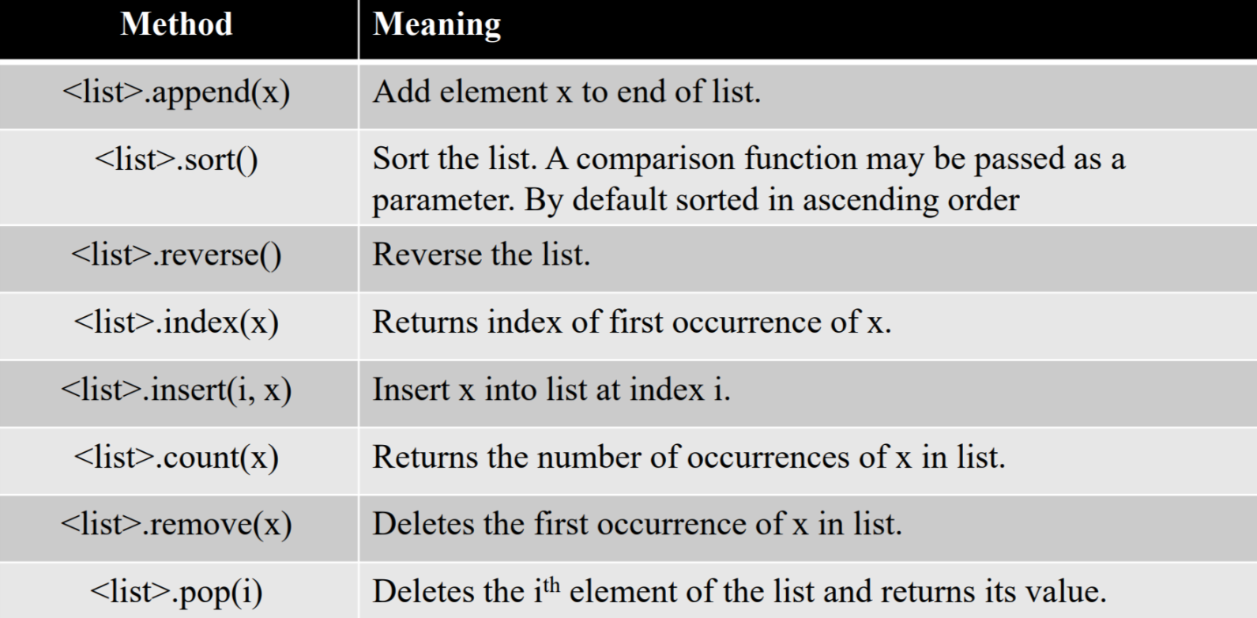

Dictionary operations

1. Key in dic -> boolean expression
2. Dic. Keys () -> a sequence of keys
3. Dic. Values () -> a sequence of values
4. Dic items () -> a sequence of tuple containing items
5. Del dic [key] -> delete that specified entry
6. Dic. clear () -> delete all the entry

Random function:

1. Rnd. Randrange (num): select a random number from 0 up to num (excluding num)
2. Rnd. random () -> range is from 0 up to 1
3. Rnd. Seed (any number)
4. Rnd. Choice ([containing number])

Graphical user interface (GUI)

Win = gx. graphWin ()

Win. Close ()

Gx. setFill (“colour”)

Point. getX (): get the X position of the point

P = gx. Point (num, num)

p. draw ()

the difference between identifiers and variables

identifier is used to name a function, variable, or structure, etc.

variable is used to name a memory location, which holds a value

all identifiers are not variables,

but all variables are identifiers

type () is used to check the type of variable

/: floating point division

//: integer division

%: the remainder of integer division

Absolute function doesn’t belong to math library